**NAAN MUDHALVAN-IBM(AI) PROJECT**

IBM AL 101 ARTIFICIAL INTELLIGENCE-GROUP 1(TEAM 5)

**PROJECT TITLE:**

CREATE A CHATBOT USING PYTHON

TEAM MEMBERS:

**Banupriya. S**(110321121005)

**Vinodhini. V**(110321121047)

**Jeevitha. B**(110321121013)

**Kalaipriya. S.G**(110321121016)

**Sandhiya. S**(110321121033)

**Problem Statement: Building a General-Purpose Chatbot**

**Background:**

In the digital age, chatbots have become an integral part of online communication. Organizations and individuals use chatbots for a wide range of purposes, from customer support to information retrieval and entertainment. The objective is to create a versatile chatbot that can engage in meaningful conversations and assist users across different domains.

**Let's take a quick look at these steps.**

1. Define Goals For Your Chatbot.
2. Decide A Communication Channel.
3. Design Conversational Language And Architecture.
4. Choose Apps For Integration.
5. Data Collection. 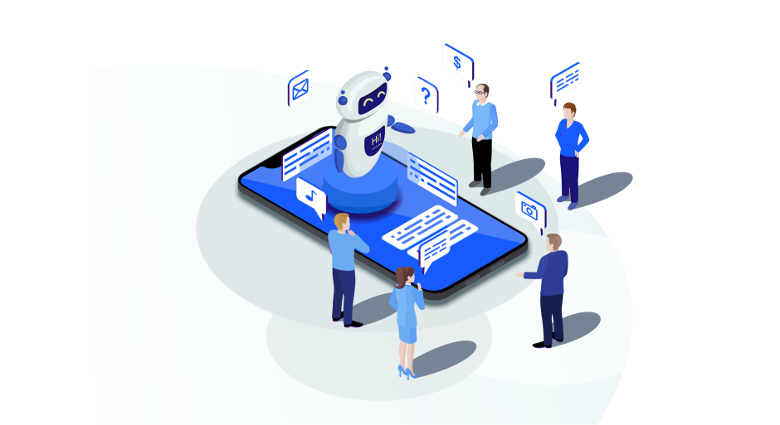
6. Select Development Platform.
7. Dialogue Flow Implementation.
8. Testing And Deployment.

**Requirements:**

**1.Chatbot Framework**:

Develop a chatbot using Python that can engage in text-based conversations with users.

**2. User Input Handling**: Implement a mechanism for the chatbot to receive, understand, and process user input in a way that feels natural and intuitive.

**3. Response Generation**:

Train the chatbot to generate contextually relevant and coherent responses to user queries or statements. Responses should make sense in the context of the conversation.

**4.Multi-domain Capability**:

Ensure that the chatbot can handle conversations on a variety of topics or domains. It should be able to switch between different conversation topics seamlessly.

**5.User Interaction:**

Design the chatbot to provide a user-friendly and engaging conversational experience. This includes appropriate greetings, farewells, and handling of user queries or requests.

**6.Error Handling:**

Implement robust error handling to gracefully handle situations where the chatbot doesn't understand the user's input or encounters unexpected issues.

**7.Extensibility:**

Make the chatbot extensible, allowing for easy integration with additional functionality or external data sources.

**8.Testing:**

Conduct comprehensive testing to ensure the chatbot performs well and provides meaningful responses in various conversation scenarios.

**9.Deployment:** Deploy the chatbot on a suitable platform, whether it's a website, messaging app, or custom application.

**Deliverables:**

• A functional chatbot built in Python, meeting the specified requirements.

• Documentation detailing how to use, maintain, and extend the chatbot.

• Test reports demonstrating the chatbot's performance in different scenarios.

• Deployment instructions for putting the chatbot into production.

**Constraints:**

• The chatbot's primary language for interaction should be English, but support for additional languages can be a future enhancement.

• Ensure that the chatbot respects data privacy and adheres to any relevant regulations.

• Consider the limitations of the chosen platform for deployment (e.g., web server, messaging app, etc.).

**Evaluation Criteria:** The success of the project will be evaluated based on:

• The chatbot's ability to engage in meaningful and coherent conversations.

• Versatility in handling conversations across different domains.

• User-friendliness and engagement of the chatbot's interface.

• Robust error handling and graceful degradation during issues.

• Extensibility and potential for integration with external systems.

• Performance and reliability in a production environment.

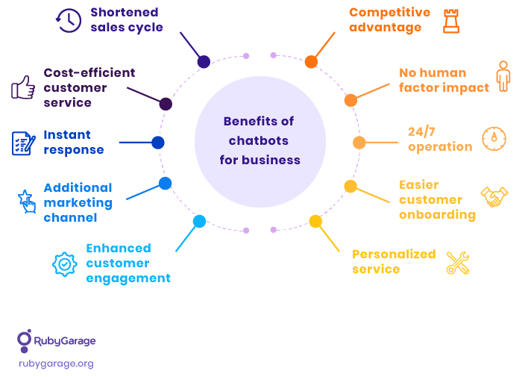

**Simple step:**

**Creating a chatbot in Python can be a fun and educational project. Here's a simple example of how to create a basic chatbot using Python:**

python

import random

# Define a list of greetings and responses

greetings = ["hello", "hi", "hey", "howdy"]

responses = ["Hello!", "Hi there!", "Hey!", "How can I help you today?"]

# Define a function to generate a response

def chatbot_response(user_input):

user_input = user_input.lower()

if user_input in greetings:

return random.choice(responses)

else:

return "I'm just a simple chatbot. I don't understand that."

# Main loop for the chatbot

while True:

user_input = input("You: ")

if user_input.lower() == "bye":

print("Chatbot: Goodbye!")

break

response = chatbot_response(user_input)

print("Chatbot:", response)

This basic chatbot recognizes a few simple greetings and responds with random replies. It will continue the conversation until you type "bye."

You can expand and improve this chatbot by adding more responses, handling different types of user input, and even integrating natural language processing libraries like NLTK or spaCy for more advanced interactions. Additionally, you could use external APIs for more specific tasks like weather information or news updates.

**IMPORTANT NOTES:**

Depending on your specific use case or industry, you may need to tailor this problem statement to address more specialized requirements. This problem statement provides a foundation for creating a versatile chatbot, and you can adapt it to meet your specific project goals and constraints.